Locating web elements by XPath
What is Xpath?
Xpath is a query language for selecting nodes from an XML document. While DOM is the recognized standard for navigation through an HTML element tree, XPath is the standard navigation tool for XML.XPath is used everywhere where there is XML. XPath is a very powerful language to express which element to identify.If you use it correctly, it can produce very reliable and low maintenance locators, but if you use it incorrectly, it can create very brittle test cases.
Pros:
–Allows very precise locators
Cons:
–Slower than CSS
–Relies on browser’s XPath implementation which is not always complete (especially on IE) and as such is not –recommended for cross-browser testing.
Lets go through different ways we can use Xpath to locate elements:
Absolute path:
driver.findElement(By.xpath("html/body/div/p/input"));
Relative path:
driver.findElement(By.xpath("input"));
Special Attributes:
Tag with attirbute value:
driver.findElement(By.xpath("//input[@id='username']"));
Any tag with id:
driver.findElement(By.xpath("//*[@id='itemid']"));
Operator ‘and’:
driver.findElement(By.xpath("//input[@type='submit'][@value='Login'"));
driver.findElement(By.xpath("//input[@type='submit' and @value='Login'"));
Operator ‘or’:
driver.findElement(By.xpath("//input[@type='submit' or @class='Login'"));
Attribute which starts with :
driver.findElement(By.xpath("//input[starts-with(@class,'tbl_')]"));
Attribute which ends with :
driver.findElement(By.xpath("//input[ends-with(@class,'_name')]"));
Attribute contains text:
driver.findElement(By.xpath("//input[contains(@id.'username')]"));
Match value to any attribute:
driver.findElement(By.xpath("//input[@*= 'username')]"));
Ancestor,descendant,following,following-sibling,preceding-sibling:
driver.findElement(By.xpath("//td[text()= 'item 1']/ancestor::table"));
driver.findElement(By.xpath("/table/descedant::td/input"));
Use parent to get to same-hierarchy object:
driver.findElement(By.xpath("//div/input[@class='testLog']/../button"));
Locate element by matching exact text value:
driver.findElement(By.xpath("//td/span[text()='random text"));
or driver.findElement(By.xpath("//td/span[.='random text']"));
See if Elment contains specified text:
driver.findElement(By.xpath("//td[contains(text(),'random text')]"));
Locating web elements by CSS Selectors :
What are Css Selectors ?
The CSS locator strategy uses CSS selectors to find the elements in the page. Selenium supports CSS 1 through 3 selectors syntax excepted CSS3 namespaces.Browsers implement CSS parsing engines for formatting or styling the pages using CSS syntax.
Pros:
–Much faster than XPath
–Widely used
–Provides a good balance between structure and attributes
–Allows for selection of elements by their surrounding context
Cons:
–They tend to be more complex and require a steeper learning curve.
Now lets go through different ways we can use Css Selector to locate elements:
Absolute Path:
driver.findElement(By.cssSelector("html>body>div>p>input"));
Relative Path:
driver.findElement(By.cssSelector("input"));
Regular Attribute:
driver.findElement(By.cssSelector("button[name='cancel']")); (tag with attribute value)
Special Attributes:
ID:
driver.findElement(By.cssSelector("#save"));
Tag and ID:
driver.findElement(By.cssSelector("button#save"));
Class Attribute:
driver.findElement(By.cssSelector(".xyz"));
Tag and Class Attribute:
driver.findElement(By.cssSelector("input.username"));
Tag with Attribute value:
driver.findElement(By.cssSelector("img[pic=abc]"));
Tag which has attribute:
driver.findElement(By.cssSelector("img[pic]"));
Tag which doesnt have attribute:
driver.findElement(By.cssSelector("img:not[pic]"));
The first child of a tag with id:
driver.findElement(By.cssSelector("div#students:first_child"));
The nth child of a tag with id:
driver.findElement(By.cssSelector("form#loginForm:nth_child(5)"));
Second descendent of div with id:
driver.findElement(By.cssSelector("div#ilan>p+ * +p"));
(first) tag which is enabled:
driver.findElement(By.cssSelector("button:Enabled"));
Text-Css Selectors:
See if element’s attribute contains specified text:
driver.findElement(By.cssSelector("div[id*='item_id']");
See if element contains specified text:
driver.findElement(By.cssSelector("input:contains('text')");
innerText attribute:
driver.findElement(By.cssSelector("td[innerText='text']"));
textContent: For FireFox
driver.findElement(By.cssSelector("td[textContent='text']"));
Finally What’s better ? Xpath or css selectors ?
— Css Selctors method is faster
— Browsers them selves use css selectors
— Latest browsers optimize the use of css selctors.
–Xpath – Cummon language for xml/html parsing
–Xpath is a two way search mechanism (up and down the Dom tree)
–Xpath handles the text recognition better.
So according to the requirement lets decide what to use where.

1. It’s faster;
2. It’s more readable;
3. It’s more used.

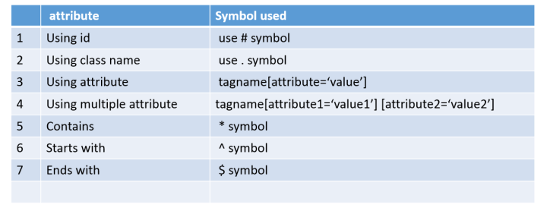

Xpath
It slow
It’s not flexible
It’s not support ie browser
It can traverse both direction down and up in the DOM

Css selectors
It is faster than xpath
It is flexible
It support all the browsers
It traverse down in the DOM

Xpath preceding-sibling :: <tag name>
https://dpastov.blogspot.com/2015/10/preceding-sibling-and-following-signling-xpath.html

Means before u want to select the items
Following –sibling :: <tag name>

Means after u want to select the items

